**The Battle of Neighborhoods**[**¶**](http://localhost:8888/notebooks/The%20Battle%20of%20Neighborhoods%20-%20Week1.ipynb#The-Battle-of-Neighborhoods)

**Looking for places in England to start a Bandeoke business**

# **Introduction (Business problem)**

England has been the cradle of diverse rock artists and bands that have changed the musical scene worlwide. From psychedelic to indie, passing trough progressive and punk, british rock has contributed to a great variety of styles and still has a great influence in present mainstream and underground scene. That's why music lovers arrive every year to visit historical music places, go to concerts and enjoy nightlife. But, what are the musical preferences of every city in England? I'll draft this by clasifying the main artists and rock bands representing every musical genre and identifying its origin city. This would help tourists keen on music to define the best cities to visit, event promoters to set the city to organize a concert and entrepreunors to start a business on music. For this project purposes, I'll focus on the point of view of an entrepreunor who is interested in starting a Bandeoke business pointed to eighties and nineties rock music (post-punk, new wave and indie). Once the best city is selected, in terms of its musical taste, I'll explore the neighborhoods in it to choice the best to set the location of the Bandeoke.

# **Data**

**For music data**

As I didn't find a dataset with rock bands classified by city of origin and genre, I'll rely on different sources like Wikipedia, where I found a list of bands by origin city in this URL:

<https://en.wikipedia.org/wiki/List_of_music_artists_and_bands_from_England>

With respect to genres, there is an infinity and several artists and bands have tried a mix of them. This makes it difficult to label a band with a specific genre what it somehow explains the absence of a dataset available to supply this information. To overcome this inconvenient and simplyfy the analysis, I decide to work with supergenres (psychedelic rock, progressive rock, hard rock, glam, heavy metal, punk, post-punk and indie) and rely on this website:

<https://musicmap.info/>

In this website there are the results of a hard classification of genres into supergenres.

**For location data**

The coordinates of neighborhoods of the city analized were obtained by scrapping Wikipedia pages, using Beautiful Soup.

# **Methodology**

1. **Data acquisition**

First, a search on music related datasets was made in different data catalogs available on the Internet, finding no satisfactory results. So, scrapping has to be made on different websites.

# **Music artists and bands from England**

A list of music artists and bands from England, by origin, is available in Wikipedia:

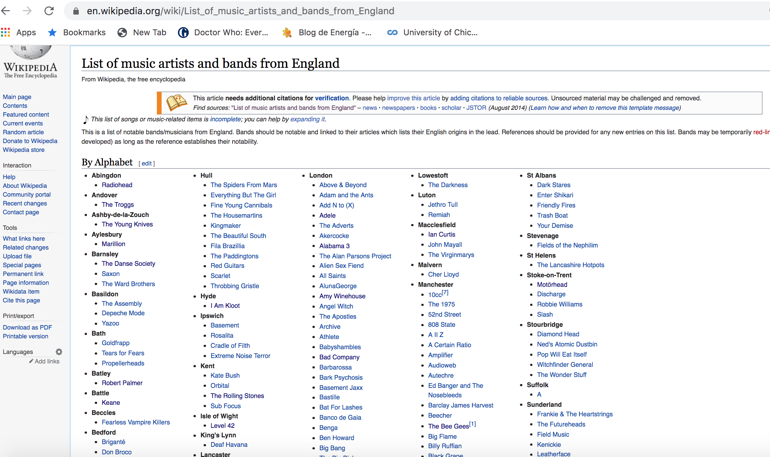

This URL was scrapped using the Beautiful Soup package, to obtain every band and artist with it respective origin. Every band and artist is linked to its own Wikipedia page, whose URL was also extracted. In the image there is an extract of the dataframe of list of artist and bands of England obtained:

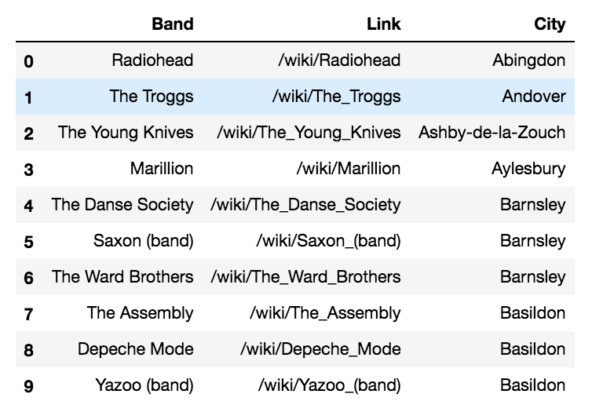

# **Music artists and bands’s musical genres**

Every URL to which the band is linked to, has background information containing the musical genres played by the band.

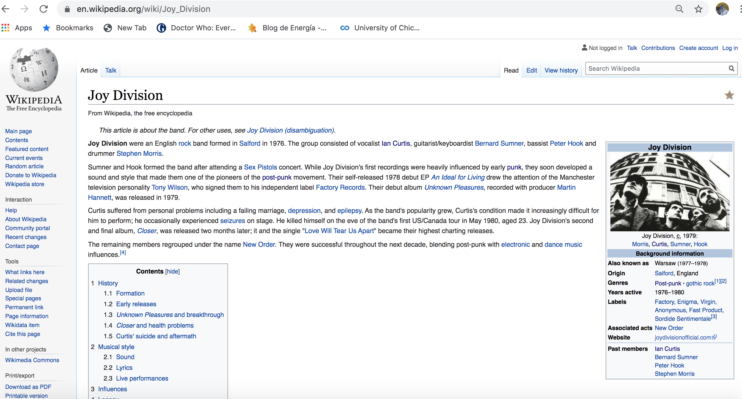

So a function to scrap every band URL was defined to extract the four main genres in each case, obtaining the next extract:

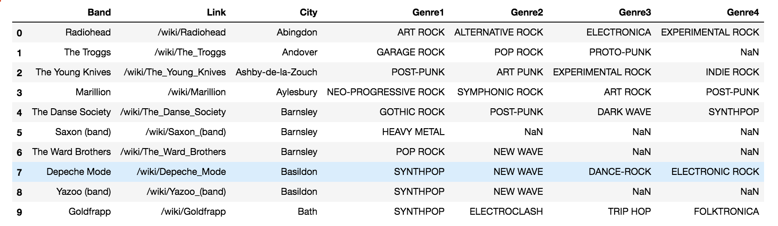

# **Music artists and bands’s musical supergenres**

As it’s shown, a band can play several musical genres, and each genre can pertain to different styles or musical trends. This results in a great variety of genres played between all bands, make it difficult to manage the data. To overcome this, a grouping of the found genres into supergenres has been carried out, taking into account the great work made in Musicmap, where a classiffication has already been made:

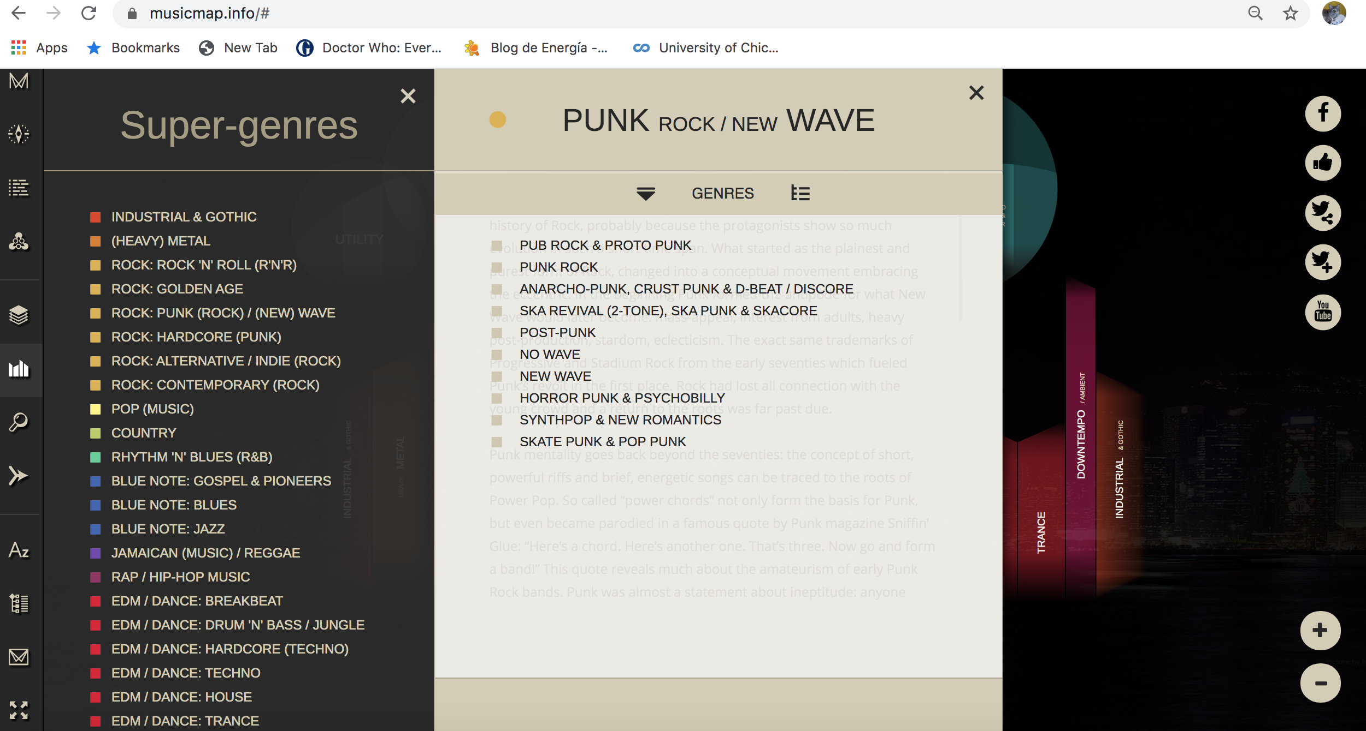

For purposes of this project, only the grouping of genres related to rock have been considered. Taking this into account, this is an extract of the results of this grouping:

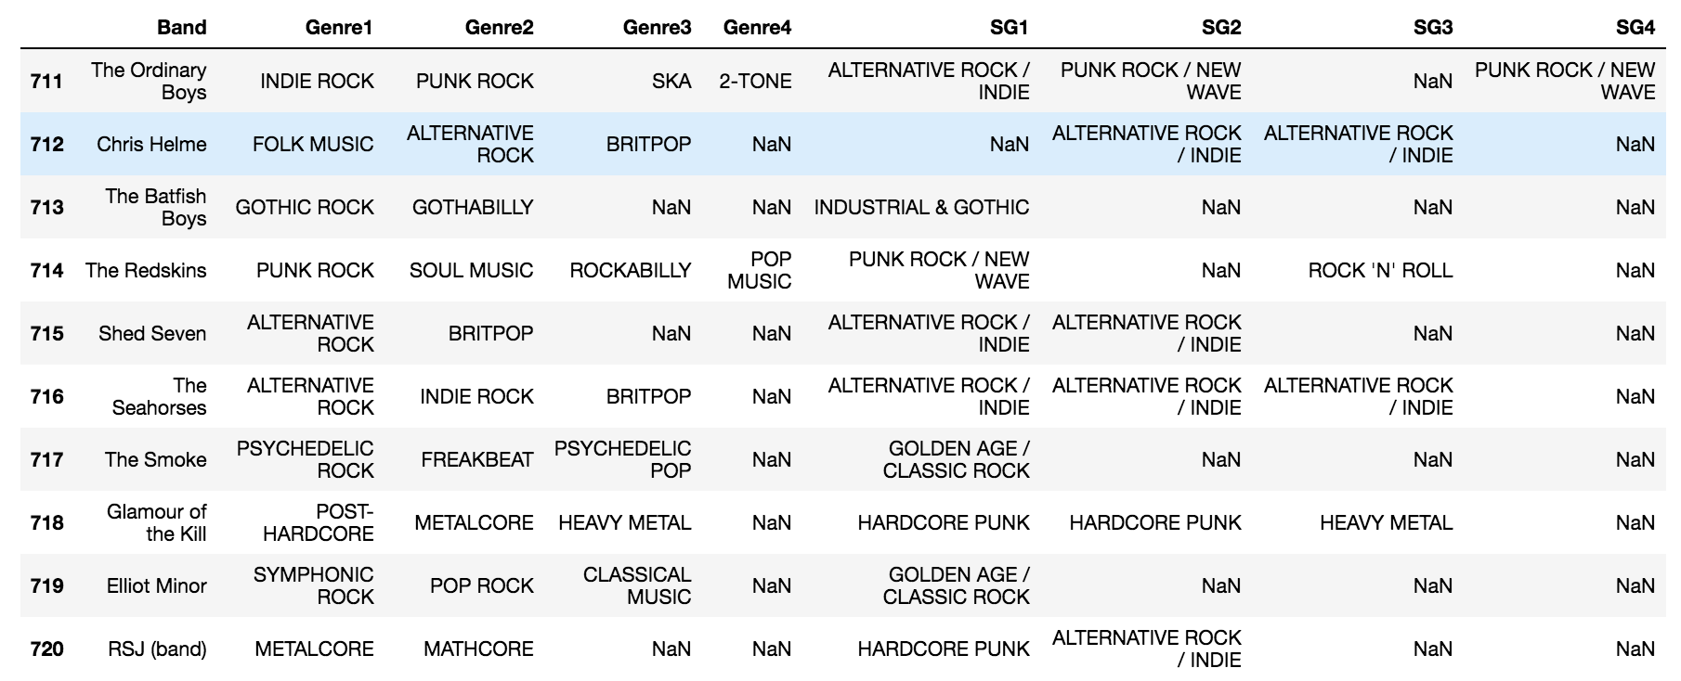

In the extract above, once more it’s seen that some bands have tried different genres. In some cases, these genres belong to a unique supergenre, but in other cases, these genres belong to different genres. To better visualize this, the categorical supergenre columns have been converted to dummy variables:

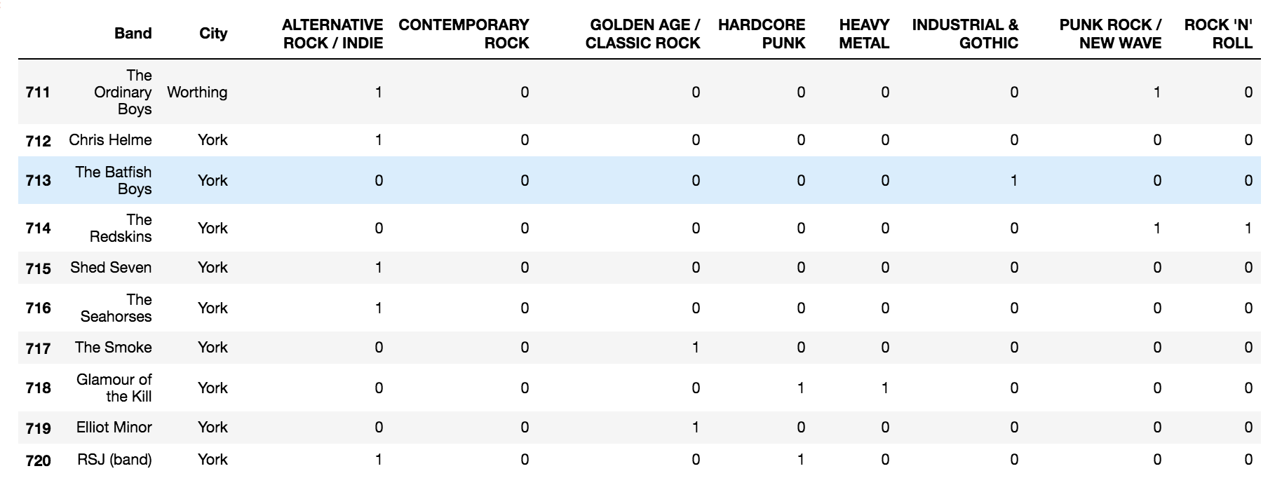

As it was pointed in the business problem, this project is focused on covering the musical taste of the followers of two styles that were very popular in the eighties and nineties, styles that also are tightly related to each other. So the “ALTERNATIVE ROCK / INDIE” and “PUNK ROCK / NEW WAVE” supergenres are grouped into one “UNDERGROUND”.

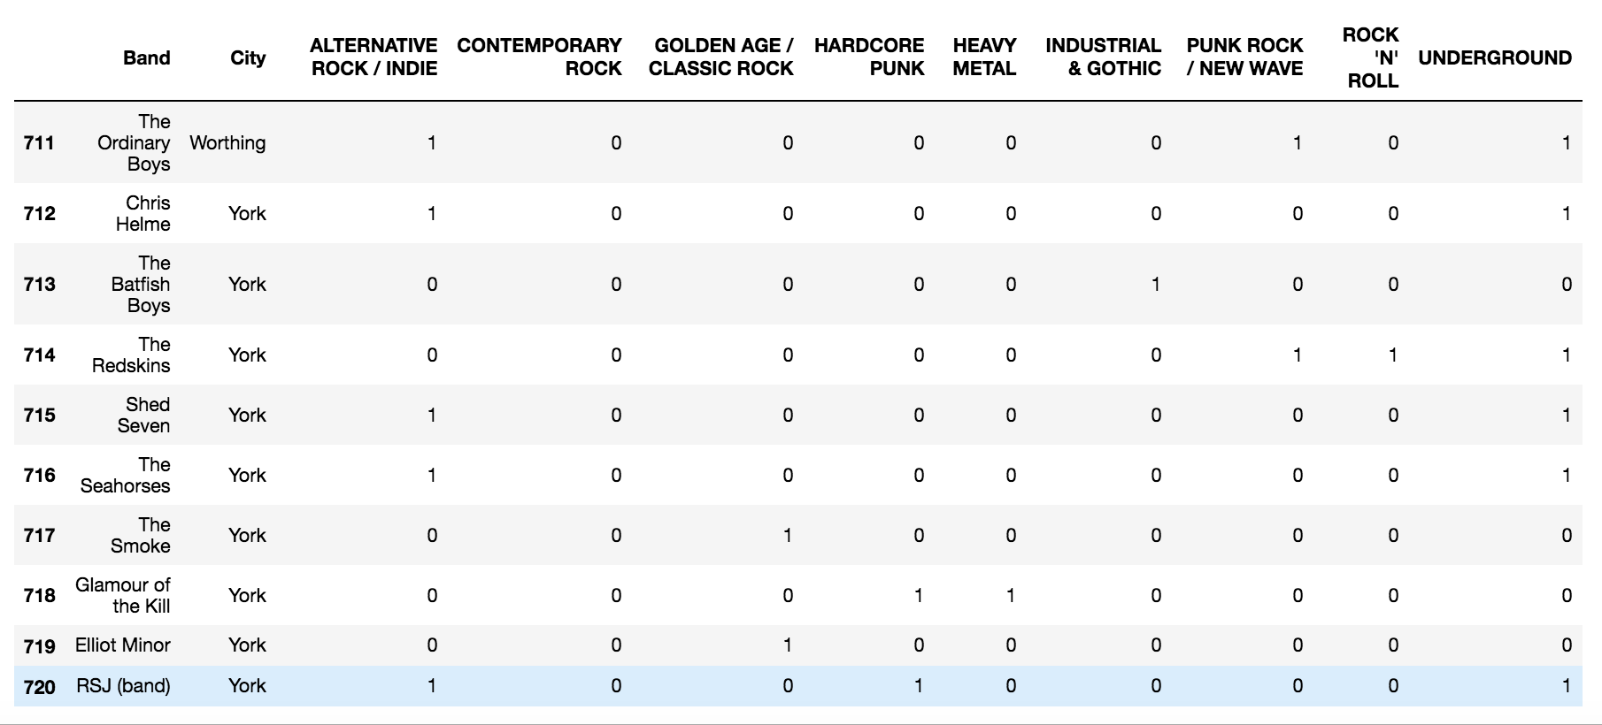

# **Cities preferences**

Grouping the dataframe by cities, we find that, in terms of number of bands, London and Manchester are the cities that like most underground style:

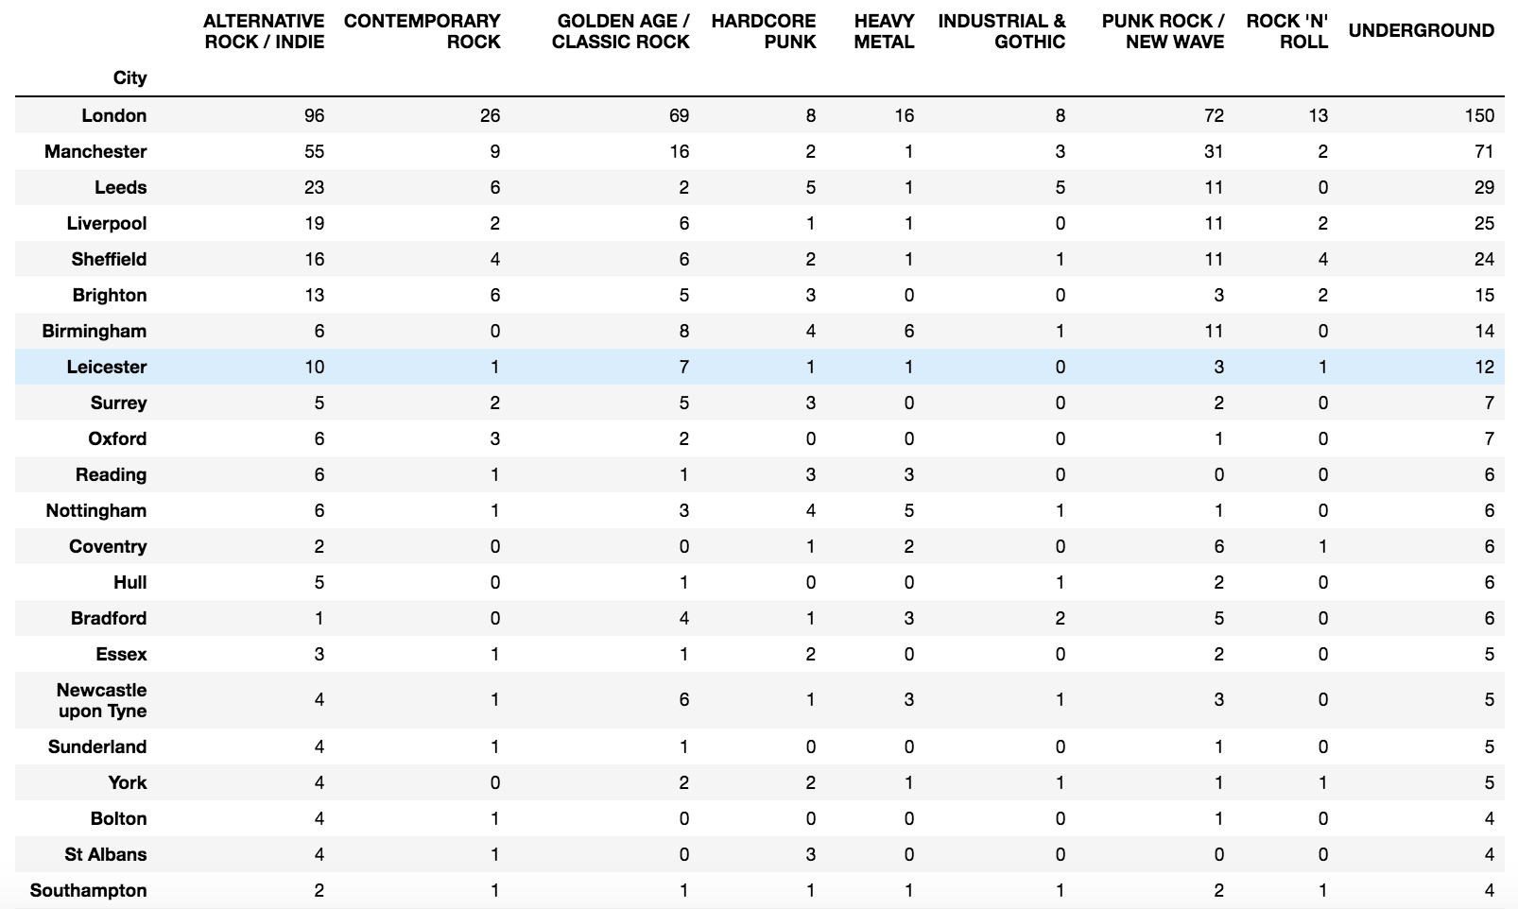

London is the city that produce most bands in England and those bandas are diverse in styles, but we have to take into account that London is denser in terms of population. Considering the density of every city, it’s found that Manchester is actually the city that produce most underground bands by every 1000 habitants:

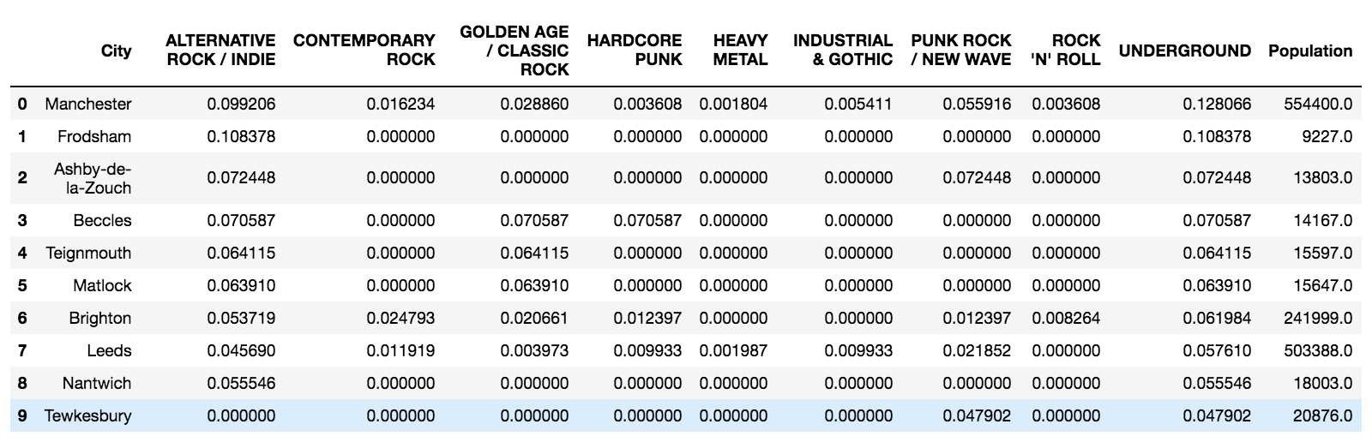

So, the areas of Manchester are explored.

# **Manchester areas data**

The areas or districts of Manchester were obtained from Wikipedia:

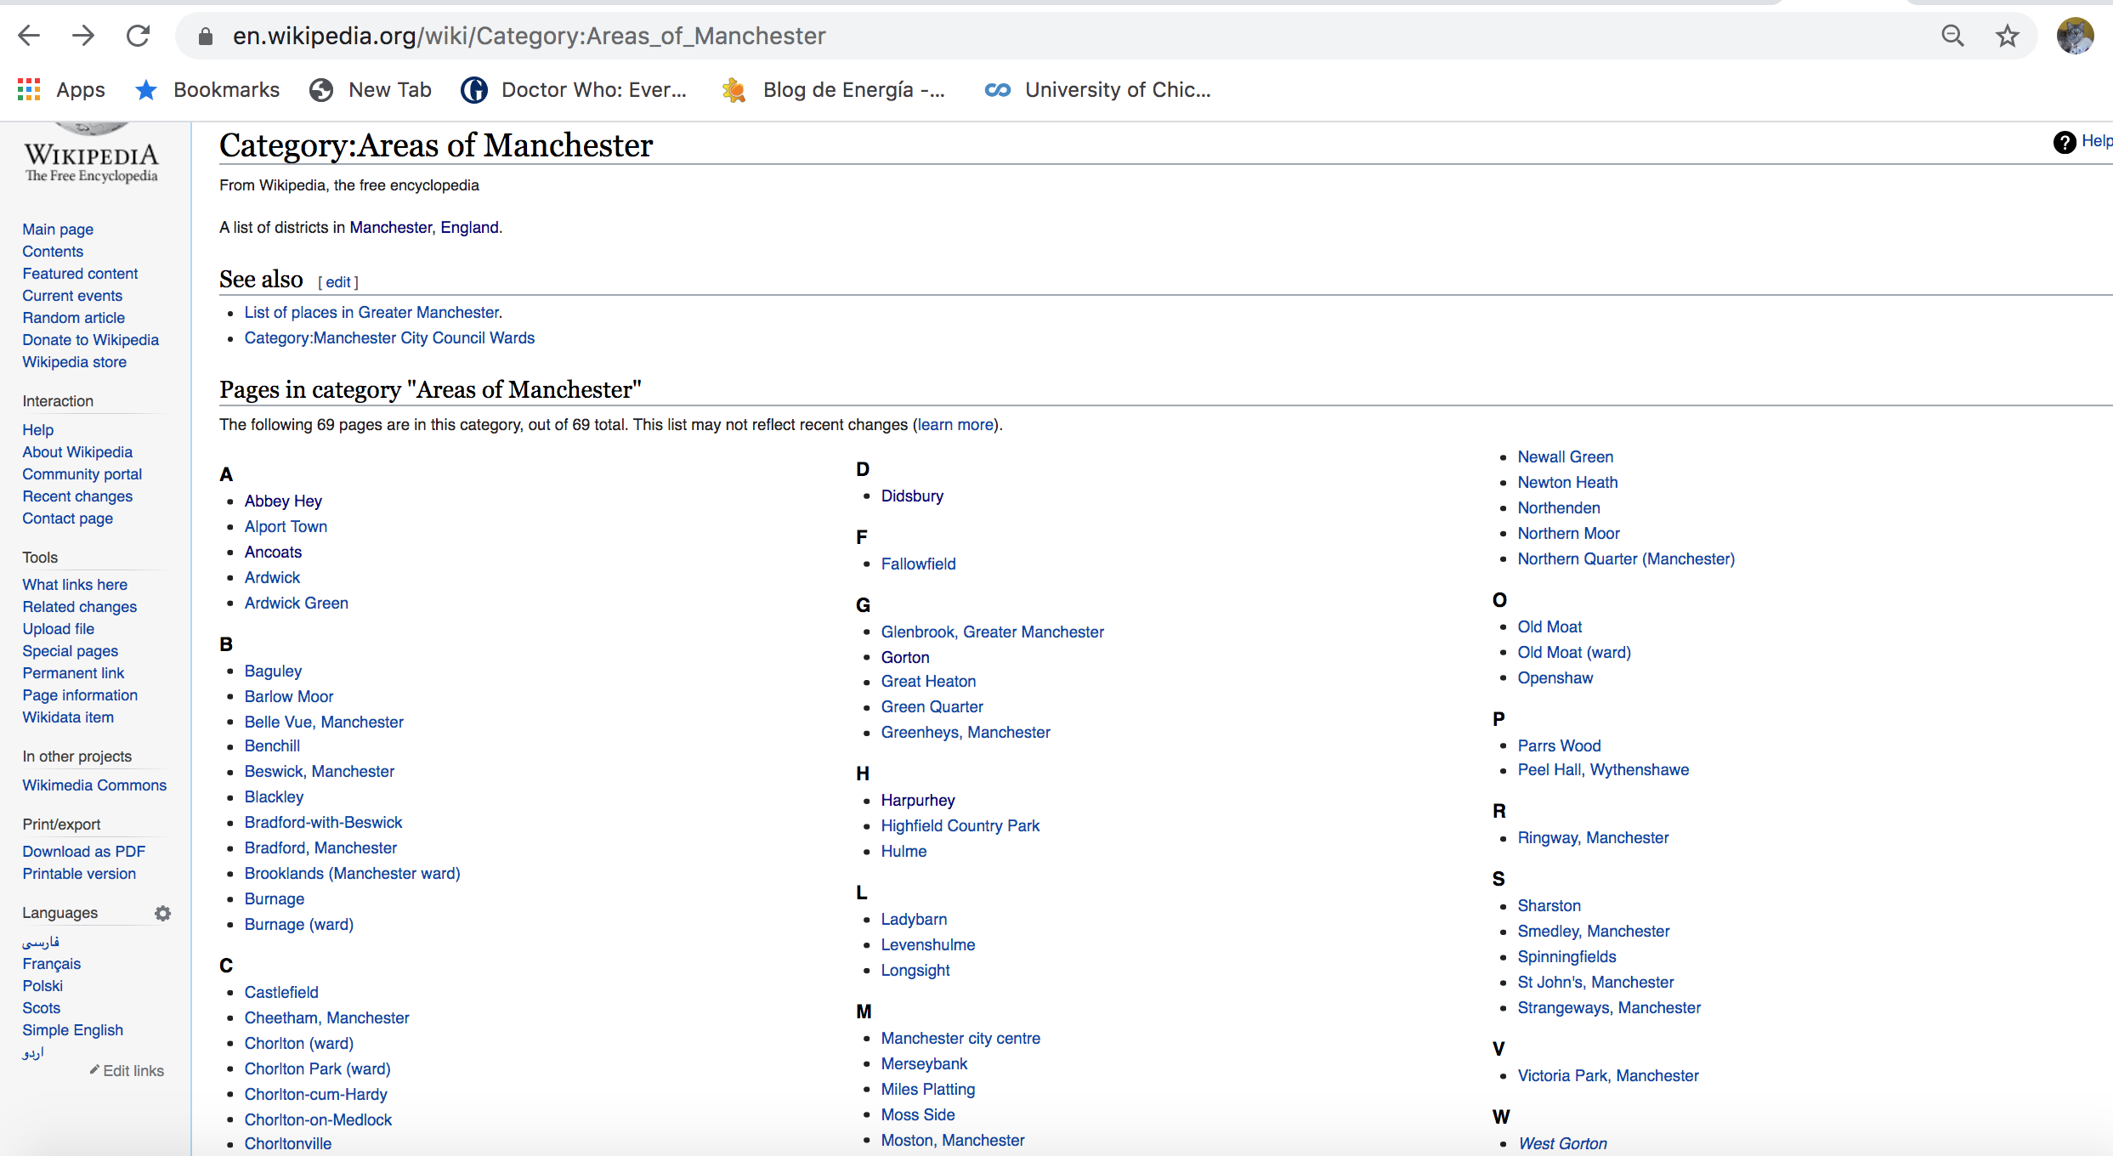

Similarly, to genres bands, coordinates for every area were obtained by browsing every reference using Beautiful Soup. This is an extract of the dataframe:

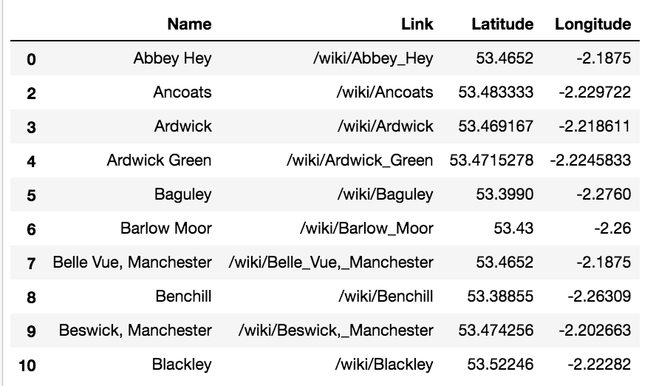

1. **Exploring Manchester areas**

For every area in the areas dataframe, the top category venues were obtained:

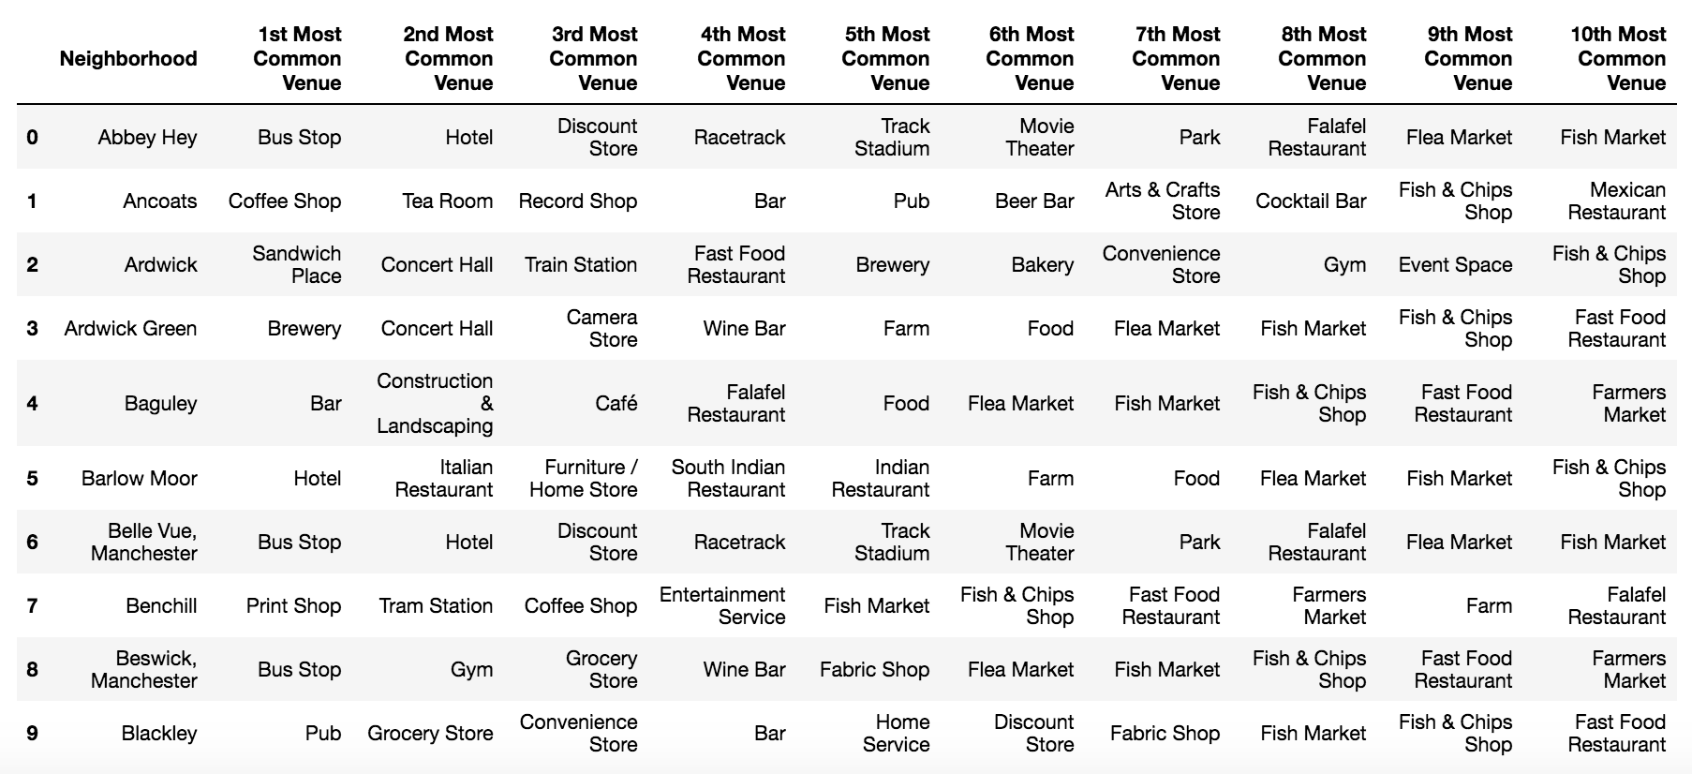

Based on its top common venues each neigborhoods was clustered:

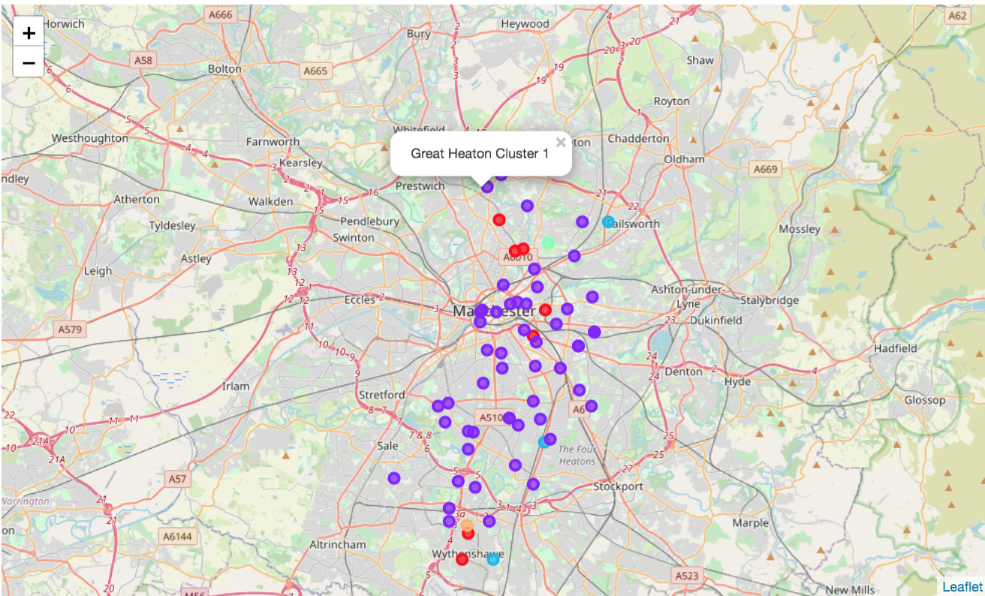

From this clusters, the cluster 1 is characterized for being commercial, containing specially venues related to music. So, it’s recommended the Bandeoke is started in this zone.

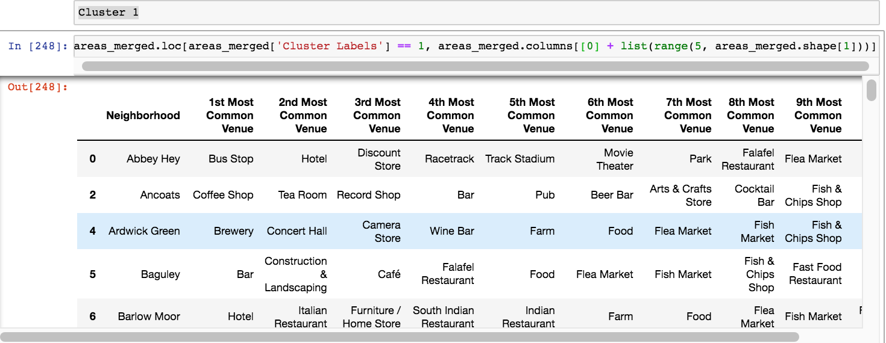

# **Results**

From analysis, London and Manchester are the cities that produce most underground style bands, but taking into account population, Manchester is the city that produce most underground style bands by every 1000 habitants.

# **Discussion**

The project has been useful for analyzing the musical preferences of every city in England, but in absence of other available information, this preference was infered from the styles of bands emerged in every city. A more precise result could have been obtained if there was information on other information such as sold disks, listened music on Spotify or watched videos on Youtube.

# **Conclusion**

The results of the project, specially the dataset of musical genres obtained, are a great instrument to make some other analysis related to music.